Heavy Vehicle National Law

National Class 1 VEHICLE STANDARDS ExEMPTION FOR Special Purpose VehicleS EXCEEDING 40 tONNES TOTAL MASS NOtice 2018 (No 1)

**Class 1 Special Purpose Vehicles Exceeding 40 Tonnes – Vehicle Standards Exemption**

|  |  |  |
| --- | --- | --- |
| **Section** | **Description** | **Page** |
|  | Introductory Notes | 2 |
|  |  |  |
| **Part 1** | **Preliminary** | **3** |
| 1 | Purpose | 3 |
| 2 | Authorising provision | 3 |
| 3 | Title | 3 |
| 4 | Commencement | 3 |
| 5 | Expiry | 3 |
| 6 | Application | 3 |
| 7 | Definitions | 3 |
|  |  |  |
| **Part 2** | **Heavy Vehicle Standards Exemption** | **5** |
| 8 | Exemption from compliance with Heavy Vehicle Standards | 5 |
| 9 | Rear overhang | 6 |
|  |  |  |
| **Part 3** | **Conditions** | **8** |
| 10  11  12 | Identification  Forward Projection  Warning lights and markings | 8  8  8 |
| 13 | Carrying additional equipment | 8 |
| 14 | Operation of State and Territory schedules | 9 |
| 15  16 | Speed Limit  Visibility | 9  10 |
|  |  |  |
| **Schedule 1** | **South Australia** | 11 |
| **Schedule 2** | **New South Wales** | 11 |
|  |  |  |

**INTRODUCTORY NOTES**

This *National Class 1 Vehicle Standards Exemption for Special Purpose Vehicles Exceeding 40 Tonnes Total Mass Notice 2017 (No 1)* (the Notice) provides exemptions from the requirements of the *Heavy Vehicle (Vehicle Standards) National Regulation* (HVVS) for certain types of Special Purpose Vehicles (SPVs) with a total mass exceeding 40t.

These exemptions only apply if a vehicle meets the conditions set out in the Notice.

**Please be aware that this Notice only provides exemptions from heavy vehicle standards. To operate on the road network a separate access authority (notice or permit) must be obtained.**

***SPVs operating under this Notice***

This Notice only applies to a Class 1 SPV that is a motor vehicle with a total mass exceeding 40t.

Examples of SPVs to which this Notice applies are:

* Carrier mounted mobile cranes such as all terrain mobile cranes.
* Carrier mounted mobile cranes with trailer dollies.
* Truck mounted SPVs such as drilling rigs, mobile concrete pumps and cranes.

This Notice does not apply to certain types of SPVs including:

* SPVs with a total mass of 40t or less. (Refer to *National Class 1 Special Purpose Vehicle Notice 2016 (No 1)*).
* SPV trailers or other non-motorised SPVs.
* SPV combinations (e.g. a prime mover towing a special purpose trailer).

***Notice Structure: Exemptions, Conditions and Schedules***

This Notice provides exemptions from certain heavy vehicle standards (Part 2). Apart from these exemptions, a vehicle operating under this Notice must meet all other applicable requirements set out in:

* the *Heavy Vehicle (Vehicle Standards) National Regulation*
* the *Heavy Vehicle (Mass, Dimension and Loading) National Regulation*

In addition to the conditions set out in the main Notice, some States have their own schedule which includes conditions. These schedules and their conditions also form part of the Notice (Schedule 1 & 2).

# PART 1: PRELIMINARY

## Purpose

This Notice exempts certain types of Class 1 Special Purpose Vehicles (SPVs) with a total mass exceeding 40t from certain prescribed heavy vehicle standards

## Authorising Provision

This Notice is made under section 61, Division 2, Chapter 3 of the *Heavy Vehicle National Law* (HVNL) as in force in each State and Territory.

## Title

This Notice may be cited as the *National Heavy Vehicle Standards (Class 1 Special Purpose Vehicles Exceeding 40 tonnes Total Mass) Notice 2017 (No.1)*.

## Commencement

This Notice commences on the date it is published in the Commonwealth Gazette.

## Expiry

This Notice expires five years after the date of commencement.

## Application

1. This Notice applies in all participating jurisdictions.
2. This Notice applies to a heavy motor vehicle that:
   1. is a Class 1 heavy vehicle that is a SPV; and
   2. has a total mass more than 40t; and
   3. complies with the dimension requirements set out in Part 2 of this Notice; and
   4. is not excluded by a condition of this Notice.

## Definitions

1. Unless otherwise stated, words and expressions used in this Notice have the same meanings as those defined in the HVNL.
2. In this Notice -

Additional Equipment means tools, substances and readily removable equipment required for the normal use of the vehicle. Examples include:

Table 1 Additional Equipment

|  |  |
| --- | --- |
| ***SPV Type*** | ***Additional Equipment*** |
| **Cranes** | Slings, Hooks and Timbers. |
| **Concrete Pumps** | Water, Cement, Fly Ash and Extension Pipes |
| **Drill Rigs** | Drill stems, Rigging Tools |
| **Fire trucks** | Fire-fighting Equipment, Quantity of Water and Foam |

All terrain mobile crane means an SPV that has all of the following features and requirements:

1. is a mobile crane; and
2. has two tyres per axle (a dolly operating a part of an all-terrain mobile crane may be fitted with 4 tyres per axle); and
3. has at least 50% of its axles steerable; and
4. is not a truck mounted SPV; and
5. has on road and off road capability.

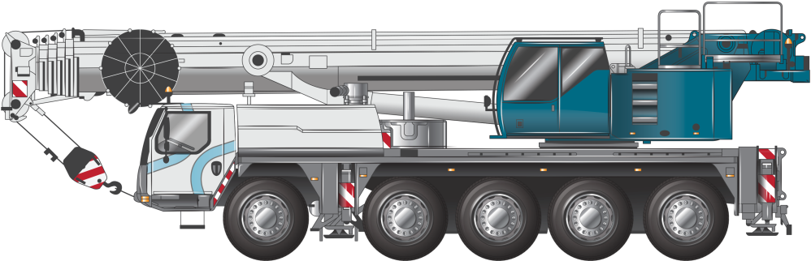

Figure 1 Illustrative example of an all terrain mobile crane

Carrier mounted SPV means a heavy motor vehicle that is an SPV where the axles, chassis frame and main equipment are built as an integral vehicle unit, and which cannot be divided without extreme effort, expense or risk of damage to it. A carrier mounted SPV is not a truck mounted SPV.

***Example:*** *Most mobile cranes including all terrain mobile cranes and truck cranes are carrier mounted SPVs.*

Ground contact width means:

1. in relation to an axle, the distance between the outermost point of ground contact of the outside tyres on each end of the axle; or
2. in relation to an axle group, the greatest ground contact width of all the axles in the group.

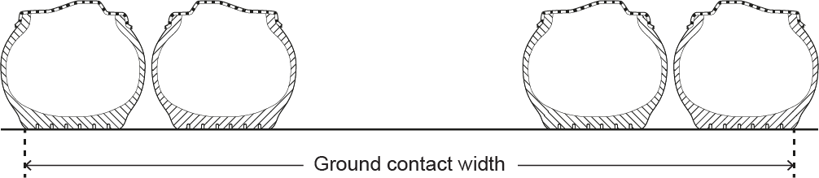

Figure 2 Illustration of ground contact width of an axle

Mobile concrete pump means a heavy motor vehicle with a component that can be used to transfer liquid concrete by pumping.

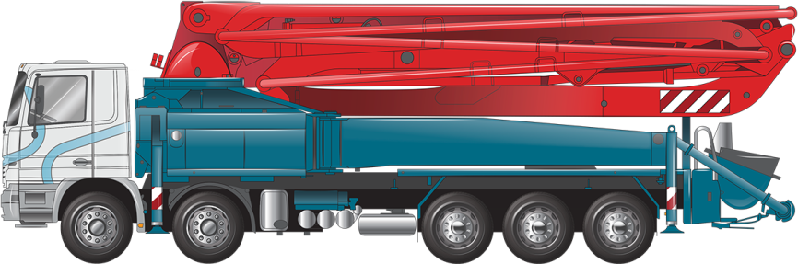

Figure 3 Illustrative example of a mobile concrete pump

MDL Regulation means the Heavy Vehicle (Mass, Dimension and Loading) National Regulation, as amended from time to time.

Mobile crane means a heavy motor vehicle that is:

1. equipped with a crane or other lifting device; and
2. designed primarily for raising, moving and lowering a freely suspended load.

***SPV*** means :

(a) a motor vehicle or trailer, other than an agricultural vehicle or a tow truck, built for a purpose other than carrying goods; or

(b) a concrete pump or fire truck.

Total Mass of the SPV means:

1. the mass of the SPV; and
2. the mass of any additional equipment.

Truck mounted SPV means an SPV built using an Australian Design Rule (ADR) compliant heavy vehicle cab chassis.

***Example:*** *Most concrete pumps and drilling rigs are truck mounted SPVs.*

# PART 2: HEAVY VEHICLE STANDARDS EXEMPTION

## Exemption from compliance with Heavy Vehicle Standards

A vehicle of the type set out in Column 2 of Table 2 is exempt from complying with Schedule 2 Section 34(1) of the *Heavy Vehicle (Vehicle Standards) National Regulation* in so far as it requires compliance with the prescribed dimension requirement specified in Column 3, provided that the dimension does not exceed the limit specified in Column 5.

While this notice allows registration of an SPV (provided all the conditions set out in the Notice are met) it does not provide any approvals in regards to the vehicle’s access to the road network.

For information relating to road access is provided in section 17 below.

**Table 2 MDL Regulation Exemptions and Dimension limits**

| ***Column 1*** | ***Column 2*** | ***Column 3*** | ***Column 4*** | ***Column 5*** |
| --- | --- | --- | --- | --- |
| ***Item No.*** | ***Type of vehicle operating under this Notice*** | ***MDL Regulation  Schedule 6 exemption*** | ***Dimension*** | ***Limit*** |
| **1** | Any | Section 8 | Height | 4.6m |
| **2** | Any | Section 7 | Width | 3.5m  (or as specified in the NSW Schedule[1] or the SA Schedule[2]) |
| **3** | Any | Section 3 | Length | 14.5m |
| **4** | Mobile cranes | Section 3 | Length | 15.5m |
| **5** | Carrier mounted mobile crane fitted with dolly trailer | Section 3 | Length | 25m |
| **6** | Any SPV up to and including 5-axles and no greater than 15.5m in length | Section 5(1)(c) | Distance from the rear overhang (ROH) line to the rear of an SPV | Lesser of 4.0m or 90% of the wheelbase |
| **7** | Any SPV up to and including 5-axles and no greater than 15.5m in length | Section 5(1)(c) | Distance from the ROH line to the rear of an SPV | 4.0m to 4.5m if vehicle complies with Section 9 |
| **8** | Any SPV with 6 or more axles and/or greater than 15.5m in length | Section 5(1)(c) | Distance from the ROH line to the rear of an SPV | 4.5m if vehicle complies with Section 9 |

[1] Please refer to Section 1(1) of NSW schedule.   
[2] Please refer to Section 1(1) and 1(2) of SA schedule.

## Vehicle turning performance

1. The distance from the ROH line to the rear of the SPV is permitted to be up to, and including, 4.5m if the three following conditions are met:
2. The tail swing performance and the low speed swept path performance of this vehicle, as measured in accordance with the PBS Scheme Standards and Vehicle Assessment Rules, do not exceed 0.30m and 7.40m respectively. This condition means that the vehicle operates within the PBS Level 1 tail swing and low speed swept path performance; and
3. The vehicle has a turning circle of 25m diameter or less; and
4. A certificate issued by a PBS assessor accredited under the PBS Scheme Assessor Accreditation rules, certifies that the assessed vehicle complies with the PBS Level 1 tail swing and low speed swept path performance standards. This certificate must be carried in the vehicle whenever it is travelling under this Notice. It must identify the vehicle uniquely by describing the base vehicle apparatus (i.e. concrete pump model) and Vehicle Identification Number (or chassis number for non-truck based SPVs). It must also contain scaled drawings showing the vehicle dimensions, vehicle low speed swept path and tail swing together with the actual assessment result values and corresponding Level 1 performance limits.

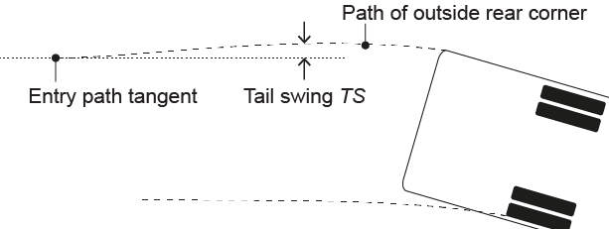

Figure 4 Illustration of tail swing performance measure   
(Source: NHVR/NTC Performance-Based Standards Scheme – the Standards and Vehicle Assessment Rules).

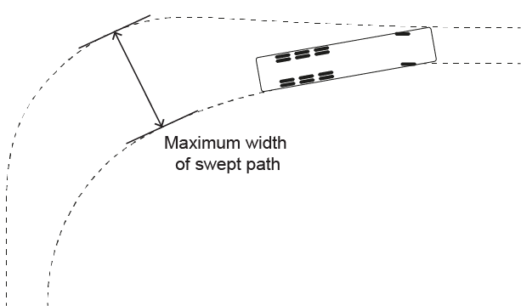

Figure 5 Plan view illustration of Maximum Width of Swept Path, SPWmax   
(Source: NHVR/NTC Performance-Based Standards Scheme – the Standards and Vehicle Assessment Rules).

*Note-*

A comprehensive list of PBS assessors accredited under the PBS Scheme Assessor Accreditation rules is available on the NHVR website at: <https://www.nhvr.gov.au/road-access/performance-based-standards/pbs-useful-contacts>

For contact details of an AVE in your area please contact your local transport jurisdiction.

*Note-*

A certificate of conformance with PBS Level 1 Tail Swing and Swept Path performance template is available on the NHVR website at: <https://www.nhvr.gov.au/law-policies/notices-and-permit-based-schemes/national-notices>.

# PART 3: CONDITIONS

## Identification

1. SPVs must be fitted with either:
2. a manufacturer’s plate listing the vehicle’s details, or
3. an Identification Plate in the case of a truck based SPV.
4. A crane dolly must be fitted with an Identification Plate stating the relevant Approval Number.

## Forward Projection

1. SPVs, excluding mobile cranes, must not have an object projecting greater than 3.5m in front of a line transecting the centre of the steering wheel.
2. A mobile crane must not have an object projecting greater than 5.5m in front of the centre of the steering wheel, or, if operating in South Australia, as specified in Section 1(3) of SA schedule.

## Warning lights and markings

1. In addition to the requirements set out in Schedule 8, section 17(2) of the MDL, a pattern covering an area of at least 0.16m2 and consisting of diagonal stripes at least 150mm wide and alternatively coloured red and white, or black and white, must be marked on the left and right sides and extremity of any rigid projection extending more than 1.2m in front or to the rear of the body of a special purpose vehicle.
2. A SPV with a projection in front of the centre of the steering wheel exceeding 3.5m must have —
3. side marker lights on both sides of the projection, as far forward as possible. The side marker lights must be shielded from the driver’s view, but be visible to other motorists approaching from the front and sides of the vehicle, and
4. a yellow rotating warning light attached to the projection, as far forward as possible, that is shielded from the driver’s view.
5. Contrary to the requirements set out in Schedule 8, section 4 of the MDL, a warning light must be attached to the vehicle if it is wider than 2.5m or longer than 25m.

## Carrying additional equipment

1. Subject to section 13(2), an SPV must not carry goods.
2. An SPV may only carry additional equipment that is to be used in conjunction with the SPV.
3. The total mass of the additional equipment carried on an SPV must not exceed 1 tonne.
4. Fuel in the tank(s) connected to the vehicle fuel supply system is not considered as additional substances under section 13(2).
5. If a sheave block is fitted to the front of the crane, it must not impede the driver’s view of the road, traffic or pedestrians.

## Operation of State Schedules

1. A vehicle operating under this Notice must comply with the conditions set out in the Schedule and relevant access exemption for a participating jurisdiction where the vehicle is being used.

## Speed Limit

1. Any SPV fitted with hydraulic steering must be speed limited to 80 km/h. The vehicle must display a speed limited sign at the rear of the vehicle in a position where the sign is clearly visible. The sign must meet the “Speed Limited Sign Requirements” specifications below.
2. If an SPV has a top speed less than 80km/h, a sign meeting the “Speed Limited Sign Requirements” specifications below and displaying the vehicle’s top speed must be fitted in a position where the sign is clearly visible.
3. The speed limit sign must meet the following requirements:
4. Dimension detailed in figure 6 below are the minimum permitted.
5. “80” kph (or vehicle’s top speed) lettering must be a minimum of 90mm in height and black in colour
6. The “80” kph (or vehicle’s top speed) lettering must be surrounded by a red circle/border at least 10mm in width and the sign must also have a 4mm black border.
7. The words “Vehicle Speed Limited” must be in 30mm high lettering and the words spaced 20mm apart and letting in ARIAL Bold with character spacing of 40%
8. The signs background shall be silver or white and be in retro-reflective material meeting AS/NZ 1906.1 requirements.
9. The signs, reflective surfaces and letting must be made of durable material that is capable of having road grime and dirt readily removed by the use of only a cloth or soft bristle brush in combination with a mild detergent solution. Additionally, the plate must be able to withstand the effects of the cleaning techniques used within the motor vehicle industry such as steam cleaning, high-pressure hot water washing or automatic vehicle cleaning equipment.

**Figure 6 Speed Limit Sign**



**All dimensions in millimetres**

**All dimensions are minimum dimensions allowed**

**Lettering Arial Bold; character spacing 40%**

## Visibility

1. An SPV must be designed to allow the driver in the normal driving position, a view of the road, pedestrians and traffic to the front and sides of the vehicle so the driver can drive safely.
2. If a SPV has the centre of a steering control to the left of the vehicle or has a projection or section of the vehicle which obscures the driver’s vision to the rear of the vehicle, it must either:
3. be fitted with a means, such as a closed circuit television system, that provides the driver with an adequate view to the rear of the vehicle; or
4. be accompanied by 1 pilot vehicle.

## Access

To operate the SPV on the road network a separate access authority (notice or permit) must be obtained.

Further information regarding access permits and notices can be found on the NHVR website at

[**https://www.nhvr.gov.au/road-access/access-management/applications-and-forms/special-purpose-vehicle-permit**](https://www.nhvr.gov.au/road-access/access-management/applications-and-forms/special-purpose-vehicle-permit)

and

[**https://www.nhvr.gov.au/road-access/access-management/applications-and-forms**](https://www.nhvr.gov.au/road-access/access-management/applications-and-forms)

or call 1300 MYNHVR (1300 696 487)

**Dated: NN MMM 2017**

Sal Petroccitto **Chief Executive Officer**National Heavy Vehicle Regulator

# SCHEDULE 1 – SOUTH AUSTRALIA

1. South Australia conditions
2. Truck mounted SPVs (including mobile concrete pumps) must not exceed 2.5m in width.
3. All other SPVs covered by this Notice must not exceed a width of 3.1m.
4. The projection in front of the centre of the steering wheel of a SPV must not be greater than 3.5m.

# SCHEDULE 2 – NEW SOUTH WALES

1. NSW conditions
2. SPVs, other than a mobile crane, must not exceed 2.5m in width.