SATELLITE PLACING boom - single wall pipe section split
​​
A concrete pour was being performed utilising a Schwing SPB-35 Satellite Placing Boom and pump for a staircase. At 8:20am, the upper 90-degree single wall, cast iron bend located at Stage 4 of the placing boom split, resulting in loss of concrete under pressure.

The pump operator ceased the pour and notified the Hansen Yuncken Project Management team of the incident.

No workers were injured or located in the area where the pressurised concrete blew out.

circumstances
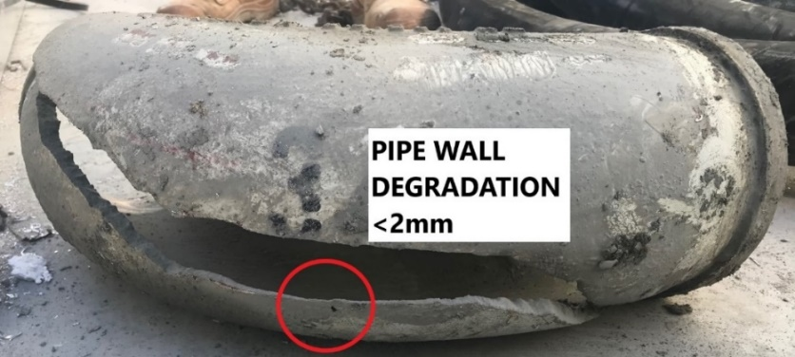
- The pump operator monitored the pump pressure, which was normal with no line blockage.
- The 90-degree “single wall” cast iron pipe bend is located at the lower rotating knuckle of the Stage 4 placing boom. This section of pipe is a single wall pipe, the rest are twin walled. Prior inspection results on the pipe bend were available – it had a wall thickness of 7.7 mm.
- Pipe thickness measurements are to be performed at the intervals and method specified in Section 6.5 of the Australian Standard AS 2550.15:2019 – “Cranes, hoists and winches - Safe use Part 15: Concrete placing equipment”. Table 6.2 “Steel Concrete delivery pipe inspection and testing requirements” requires inspection and measuring of wall thickness of single wall pipes to be performed at monthly intervals using an ultrasonic test instrument. Twin wall pipes thicknesses are visually inspected every month for impact damage and once every 20,000 cubic metres or at 12 monthly intervals (whichever occurs first) by physical measurement, usually with digital callipers. This single wall 90 degree cast pipe bend was inadvertently inspected and measured as prescribed for a twin wall pipe.
- Concrete pump and placing booms have operating hours meters fitted. Manufacturers of steel pipes provide information on the grade of steel and durability based on the volume of concrete pumped in cubic metres. This requires the pump owner/operator to calculate the volume from the hours operated and monitor the pumped volumes for twin wall pipe sections.

recommendations
- Competent person/s responsible for pipe thickness inspections are to be trained in the relevant Codes of Practice, Australian Standards, testing instrument requirements, concrete pump and placing boom manufacturers manuals and concrete delivery pipe supplier specifications.
- Pipe thickness testing equipment is to be ‘fit for purpose’ and maintained as per manufacturers specifications. In this instance the digital testing callipers used were not sufficient to reach the centre point of the pipe arc where the wall thickness had been worn away.
- When testing wall thickness using ultrasonic devices, ensure a broad range of testing locations are conducted to determine the lowest readings and the selected locations are to focus on the most affected zones, including the outer radius of the pipe bends.
- Inspections of plant are to be in accordance with relevant Legislation, Codes of Practice, Industry Codes, Australian Standards and manufacturers specifications. Pipe thickness gauges and measuring instruments are to be calibrated and have current inspection records.
- Pipe sections are to be labelled with a durable unique identification number, be rated for the maximum pressure of the pump and meet the satellite placing boom manufacturers specification for the grade of steel and type of pipe.

references
- Hansen Yuncken HYer Standard 17: Concrete Pumping
- Concrete Pumping Code of Practice 2021
- Australian Standard 2550.15:2019: Cranes, hoists and winches – Safe use Part 15: Concrete placing equipment
- Schwing SPB 35 Separate placing boom specifications and operation/maintenance manuals
- Steel concrete delivery pipe manufacturers specifications.
- Cement Concrete & Aggregates Australia – Concrete Pump Delivery Industry Guidelines

